2014 July 10 11 DIRECTIONALS
practice both sides and different positions on course

Practice GO from both sides

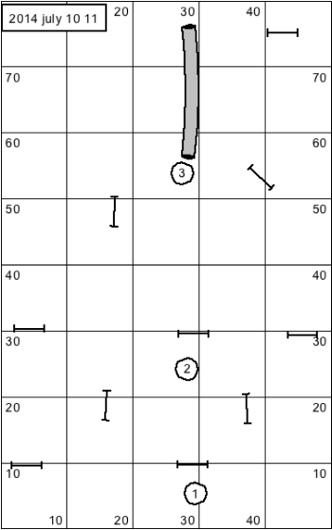

Practice OUT

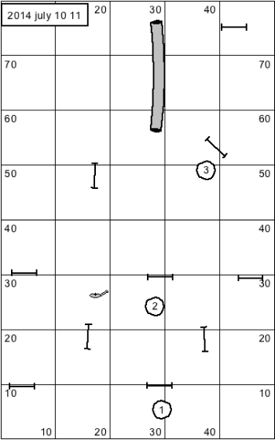

PRACTICE “COME”
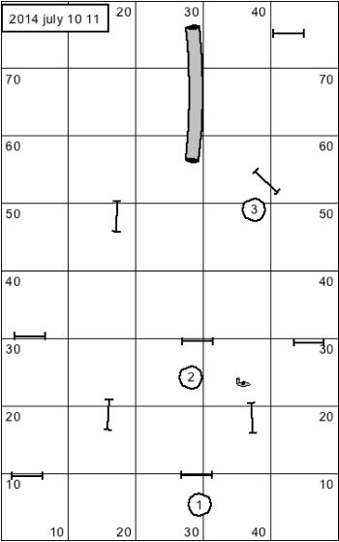

PRACTICE HERE AND SWITCH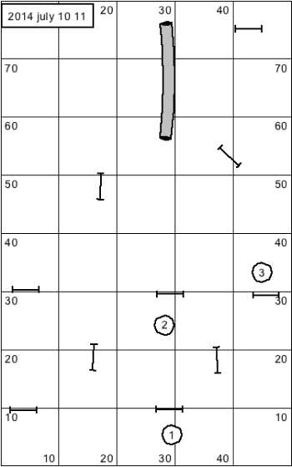

PRACTICE HERE AND FLIP
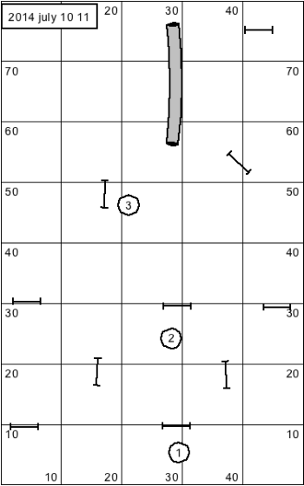

SEQUENCE # 2 ( can use jumps or hoops )

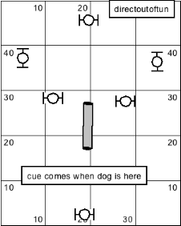

GO
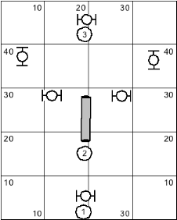

SWITCH AND HERE ( switch sides and work both directions)
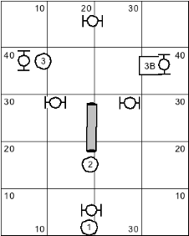

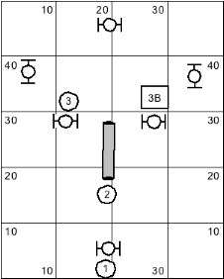

SEQUENCE 3:

