BARREL TRAINING NOV 2014
Lots of fun barrel training with this setup !
I could have left it up for weeks

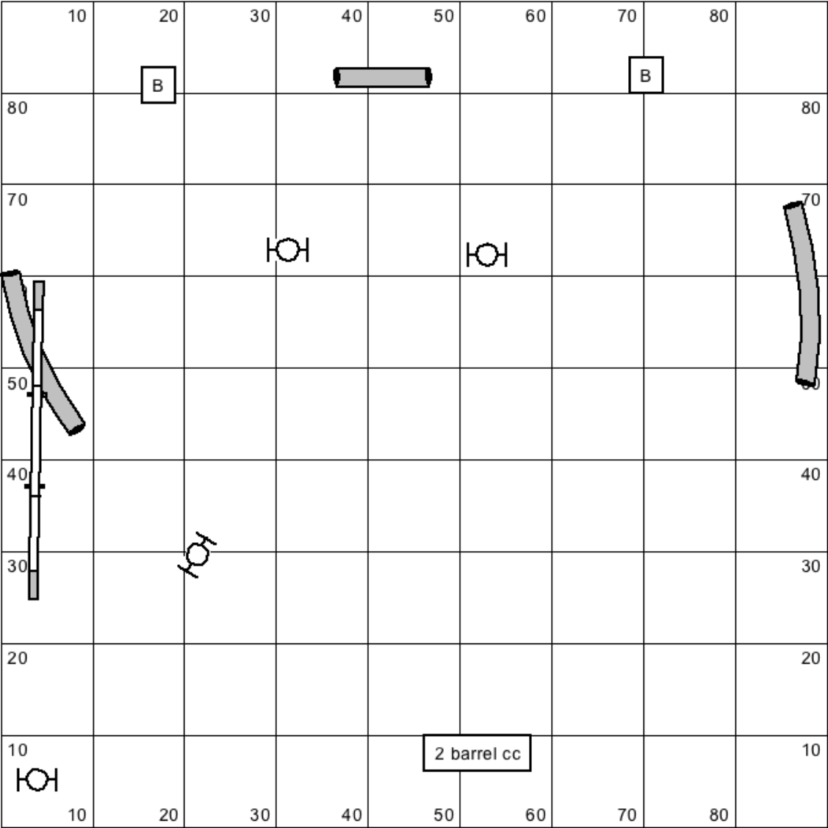
Recap of my barrel commands:
AROUND (out around barrel)
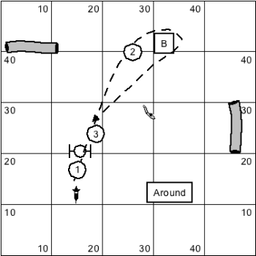

CIRCLE (Come in switch around barrel)
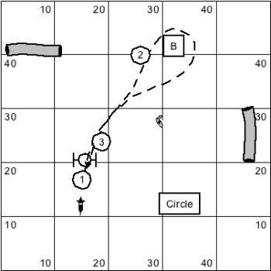

HERE
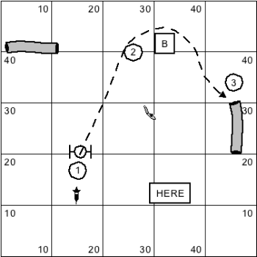

FLIP

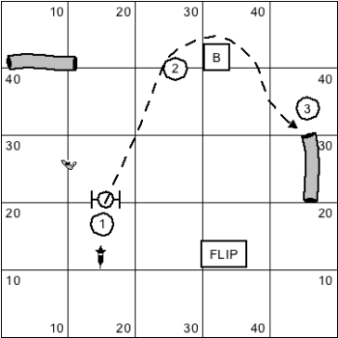

AROUND / OUT
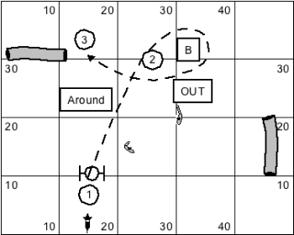

COME SWITCH
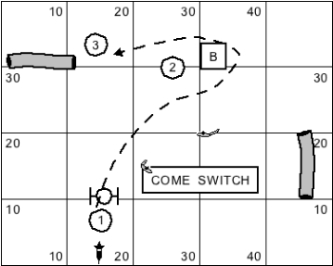

Day 1: hoop Barrel
http://youtu.be/UiT96d85TtY

Day 2: Tunnel Barrel (Barrel Tunnel Barrel Tunnel) http://youtu.be/sI05en8gTmk

Day 3: http://youtu.be/2KKSUhrm3Gk

Day 4: http://youtu.be/5QVd9XQd0Ys
Day 5: http://youtu.be/x1lU4fiiYUQ

