CUES
HERE: 180s Take the next obstacle and turn toward me. Cue occurs when the dog is at the location I placed the dog. arm is tight close to body but still draw path I expect my dog to collect prior to the jump or hoop.
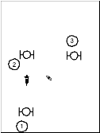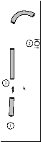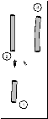

TURN PINWHEEL: Take the next obstacle and turn toward me. Cue occurs when the dog is at the location I placed the dog. left arm is out drawing path to 3. I do not expect my dog to collect but to turn towards me but move forward.

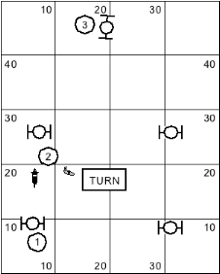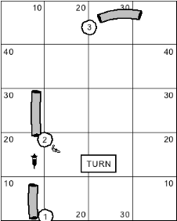

FLIP Take the next obstacle and curve away from me. This is like ‘Switch Out’

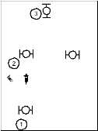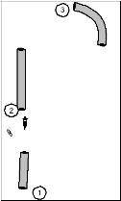

SWITCH Turn away from me Tightly
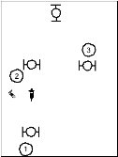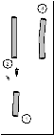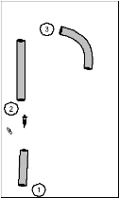

OUT Dog moves away from handler. This is NOT a turn command, but dog continues to move forward but moves away from handler. This cue is used in discriminations and serpentines.

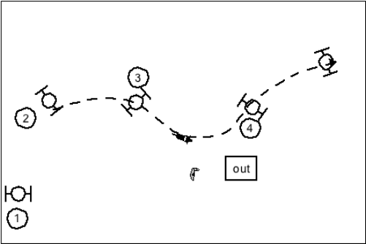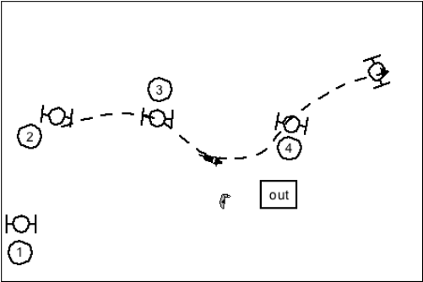

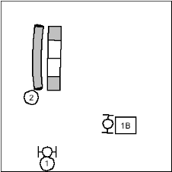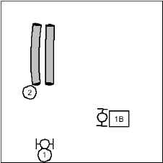

IN Dog moves toward handler. This is not a turn command.

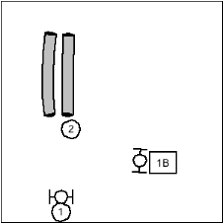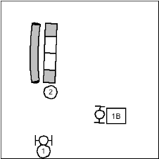

WRAP take the next obstacle and turn tightly back towards the previous obstacle.
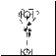

AROUND –Go out and go tightly around the barrel. So this means go to the outside of the barrel and wrap the barrel. NOTE - I use around when the dog has to go forward and around on obstacle such as a gate. I use wrap for wrapping hoops and jumps. I want the wrap to mean the dog is taking the next obstacle and almost instantaneously wrapping the obstacle. An Around means the dog has to actually go around something such as a tree or a barrel where they have to continue moving forward a bit before actually turning around.

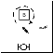

CIRCLE: Come in and go tightly around the barrel. This is something like a Come, switch around wrapped all in one. This command is for taking the inside of the barrel and then switching and tightly wrapping the barrel away from me
