DIRECTIONAL CUES Aug 2015

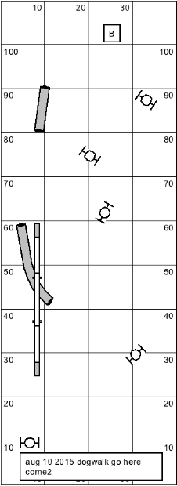

1>GO – dog on left , dog on right

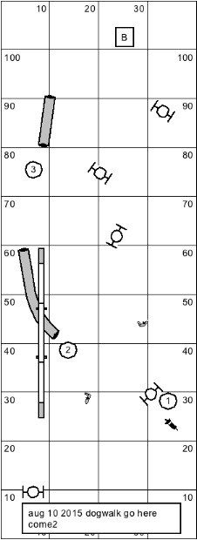

DOG on LEFT of Handler
2> HERE – TIGHT TURN TOWARDS ME

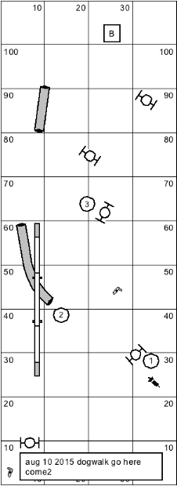

DOG on LEFT of Handler
3> COME- Turn towards me slightly and keep moving forward
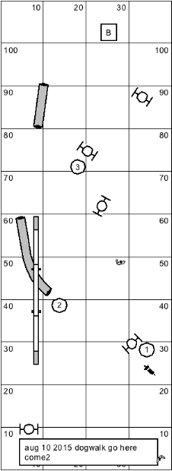

DOG on RIGHT of Handler

4> Turn TIGHT away from me
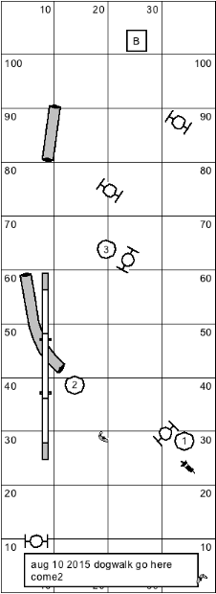

DOG on RIGHT of Handler

5> Flip- Turn away from me slightly and keep moving forward
