DISCRIMINATIONS – LESSON 1 FOUNDATION FOR DISCRIMINATIONS

Before we do actual discrimination training, we need to go over some important foundation work.

STARTLINES
IT is very important that you ONLY use a verbal command to release your dog. What I mean by this is that your dog will only get up from a stay when you say your verbal command. It doesn’t matter if you move your dog will stay until your say your release word. I do not care if my dog sits, downs or stands as long as they stay. When I am ready to release my dog, I look them in the eyeballs to re-establish eye contact. If I was leading out, I turned my back on my dog and walked away. I want to reestablish a connection with them and I do this by looking at them. I may take a deep breath. The Richard Simmons thing really works as if you take a deep breath you will relax…at least a little bit My arm moves to be ready to draw the path for the obstacles. I VERBALLY release my dog. I wait until the dog moves and THEN I will move. This ensures that your dog is not moving on your physical movement, but is only moving on your verbal release.

Startline Routine
- Dog is put on stay
- Lead out or at least stand up
- Stop moving at the location you want to lead out to
- Re-establish eye contact with your dog (take a breath)
- Verbally Release your dog – You do NOT move
- Dog starts moving
- THEN you can move !!!

WARM UP ROUTINE ----CONNECTING WITH YOUR DOG !!!!!!! CONNECT with your dog every time you ask them to ‘work’ (agility, obedience, nosework, etc)

Connecting with your dog before you run (practice or trial) is VERY IMPORTANT !!!! I don’t pull my dog out of the crate and just walk to the line. I will do shadow handling, space games, tricks before I work run them. This is very important for many reasons. First, it warms you and your dog up. You do not want to run a cold muscled dog. They can get hurt. Second, it will show you if something is wrong or off with your dog. If you always do a warm-up routine, you will get to know how your dog looks and feels. You do not have to understand the whole anatomy of the dog, but just be observant so you can see if something looks ‘off’. Third, this will help connect you with your dog! You want your dog to be focused and connected with you. By engaging with them and doing some fun fast connection games, your dog will be ready to go. Anytime your dog gets distracted, do some connection exercises.
WARMUP BODY LANGUAGE/ SHADOW HANDLING/FOCUS Teach my dogs to follow my body language as I walk around and do Switches/Here and various crosses. I use food to do this.
Here is a video of shadow handling/space games: http://www.youtube.com/watch?v=tTF4kzGe-IA
So in my videos, I have food in both hands and am feeding my dogs when they turn away from me ( I am saying switch.. you may not hear it, but I verbally say SWITCH every time I am turning my dog away from me. This is my foundation for switch). I also feed my dog for turning with me. I want my dog to walk with me and turn with my accordingly.

DISCRIMINATIONS: When I want my dog to take the outside obstacle, I am looking at that obstacle, my arm is out and I am moving on an angle towards it. Verbal cue is “OUT” Sometimes I will pick a point outside the ring (a post, a garbage can, anything) and I will continue to move towards that object until I see my dog’s cute little but in the correct obstacle. When I want my dog to take the inside obstacle, I drop my arm to my side and immediately bring it in FRONT of my body to continue to draw the path to the next obstacle. Verbal cue is “COME” or “IN”. All these cues should happen an obstacle BEFORE the discrimination. When my dog has to execute an “OUT” discrimination in the beginning of the course (or sequence), I will lead out with my arm at my side. I will release dog with a verbal cue ONLY, wait for my dog to move, I will say “OUT” and bring my arm up drawing the path to the outside obstacle. I will keep moving towards the out obstacle til I see my dogs cute little but in the tunnel. If my dog has to execute an “IN” from the startline, I lead out with my arm out at my side. I will walk parallel to the discrimination. I will verbally release dog (wait for dog to move) then drop my arm and draw path to the inside obstacle. I may say verbal command “COME” or “IN”.

Important Note: Make sure that you reward each obstacle equally. Dogs will naturally like some obstacles more than others, but you need to make sure that they are rewarded equally or even more so for the obstacles the dogs doesn’t like as much. Many people reward the heck out of contacts, but fail to reward tunnels, so many dogs will naturally choose a contact over tunnel.

CUEING YOUR DOG Cueing your dog involves 2 distinct actions. First and most important the handler needs to recognize where and when the dog must be given a cue. (Location and timing of cue)
Second, the handler must understand what cue(s) should be given. (verbal, body, what motion)

TIMING/LOCATION OF CUE: I teach my dogs to continually move forward and to vary their path based upon cue(s) that are given. It is important to recognize that cues are given BEFORE the dog takes an obstacle. This gives the dog information of the path they are to take after they complete the obstacle and is sometimes called a pre-cue. A properly given cue will allow a dog to do several things; add a stride prior to an obstacle, more efficiently perform an obstacle (take the inside or outside), and increase confidence while on course thus maintaining speed are all benefits from a properly given cue. This all creates an efficient dog’s path, keeps the handler from jerking and jamming the dog by requesting a sudden turn after an obstacle, and allows the dog to more safely execute a course. It is important to realize that the cue must be given after the dog is committed to the obstacle in front of them. The more obstacle commitment your dog has, the greater the distance from the obstacle the cue should be given.

A cue consists of up to 3 different properties; verbal commands, body language and motion. Saying the right words, giving the right body language (shoulders, arm, feet, head, eyes) and movement (acceleration/deceleration, stride length) all in a clear, crisp, consistent, calm, confident way while maintaining criteria, running with conviction and staying connected with your dog---all work together to provide a proper cue.

VERBAL CUES: So what verbal cues do you use for discriminations?
Each verbal cue should mean one distinct action !!

For me, “OUT” means dog moves away from handler. This is NOT a turn command, but dog continues to move forward but moves away from handler. This cue is used in discriminations and serpentines.

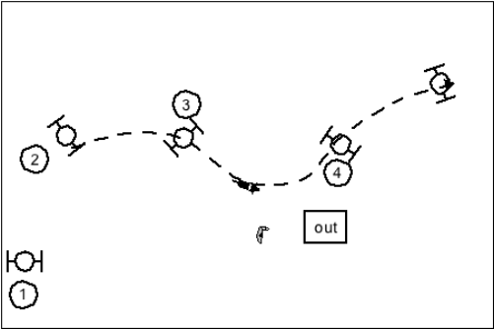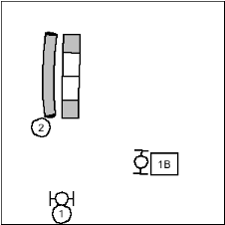

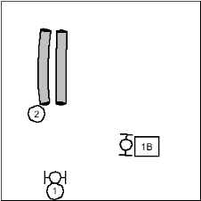

IN Dog moves toward handler. This is not a turn command.

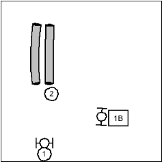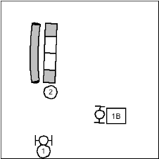

HERE: Take the next obstacle and turn towards me. This is a drastic change of direction. The dog is doing a 90 or 180 degree turn (variations in degrees).Cue occurs when the dog is at the location I placed the dog.
This is NOT a discrimination cue.

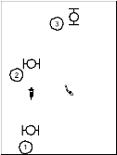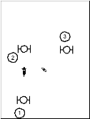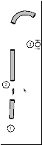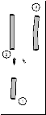

You should be using two separate commands for “HERE” turns towards you and “IN”. Below is a an example of why it is important to use to separate cues. If you wanted to take the inside tunnel, you say “IN”. If you wanted to take the hoops (1-3 second disagram) you say “HERE”. I do not want to dilute my commands. I want them to mean one thing and only thing.

Here is an example of “IN” Here is an example of “HERE”
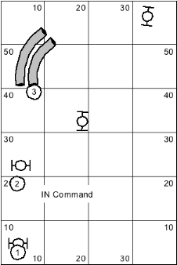
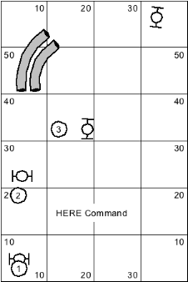

BODY LANGUAGE: It also is a good idea to write down what body language cues you use and what they mean. When my arm is out, I expect my dog to go out and stay out. If I drop my arm to my side, I expect my dog to come into me and continue working on. Be aware of your WHOLE body… not just your arms. Dogs read EVERYTHING. They watch your feet, your shoulders and even your head and eyeballs. So you have to be cognizant of what your whole body is doing. If your mouth is saying OUT but your feet and shoulders are turned in, what should your dog do? This is what I mean about having very clear consistent cues !!!
Use your body to draw the path you want your dog to run on. My arm is drawing the path and my head/eyes are looking at where I want my dog to go. I don’t look at my dog when we are running. I look at where I want my dog to go. I will look at the mouth of the tunnel, the jump, the hoop etc. Run with Intent!! Don’t flap your arms up and down. Keep your arm firm and crisp. Let me reiterate how important it is to watch where you want to go and not look at your dog. If you are looking at your dog, most likely your shoulders are opening up and giving your dog conflicting cues. If you are ‘hard eyeing” “staring” at your dog, it can be not only intimidating to the dog, it also can appear that you are not confident where you want them to go. They will be slower and less confident. Your body usually follows your eyeballs. So if your eyeballs are looking where you want your dog to go, most of the time the rest of your body follows. I am not saying to never look at your dog, I am saying you have good peripheral vision and can use that to ‘know’ where your dog is. Dogs have even better peripheral vision so that can see you too even if they are far away from you. You have to trust your dog!!
Make sure you are standing straight and not bending over. Also try to keep your arm low .or at least not higher than your shoulders. I think in terms of bowling… I bowl my dog to obstacles. This helps me keep my arm crisp, lower and I follow through. I want my arm/finger (and my whole body) to be drawing the path I want my dog to run on.
MOTION CUES: Acceleration/Deceleration/Stride Length/Pressure: When I want my dogs to continue moving forward, then I will keep moving forward. I want my dogs to know that when I am accelerating or maintain a speed and long stride they should keep moving forward. When I decelerate or shorten my stride a turn in coming up. With my motion, I will move towards my dog applying pressure when I want to push them out. Conversely, when I want my dogs to come close to me, I decrease pressure and drop my arm. Arm out –go out (or stay out) –Arm in COME IN !!

DISCRIMINATION LECTURE AND EXAMPLE WITH 2 HOOPS: https://www.youtube.com/edit?o=U&video_id=xCZH417XKpY&feature=vm

Learning Verbal and Body Language Cues with a toy only (no equipment)
It is important that your dog learns to follow your body language and understand your verbal cues. I start teaching these skills with a toy. I go in my front yard and teach my dogs the verbal cues “OUTS” , “INS” (I say come), “GO” as well as teaching them to read my body language by the direction I toss my toy. If my dog is stationary (on a stay) then I always release with a verbal cue. My verbal cue is “OK”.
I say “OK” and then the direction I want my dog to go. I will toss the toy in the direction I want me dog to go.

http://www.youtube.com/watch?v=3SFd_hR345E&feature=youtu.be

http://www.youtube.com/watch?v=s95mmCTBal4&feature=youtu.be

Timing and the placement of the rewards are very important. I always try to reward my dogs at the exact time and place they did something brilliant. If I am working “OUT” I throw my toy away from me in the direction I want my dog to go. If I am working “IN”, I throw my toys closer to me. I encourage the use of toys for teaching distance as I don’t want to reward my dog for coming into me for the treat, I want to reward for staying away from me. If you constantly give food from your hand, your dog will want to stay closer to your hand. If your dog does not like toys, you can purchase a toy that you can put food in it. My favorite food dispensing toy is the Rip and Tug Lotus Ball. Here is a video of me teaching my pups with the Lotus ball: http://www.youtube.com/watch?v=4mrU4o0GXAY&feature=youtu.be

It is important to have release word that means exercise is over and your toy is coming!! In order to avoid head checks, I teach my dogs that I will verbally release them when the exercise is over and the toy is coming. I say “YES”. So when my dogs hear me say “YES” they know that they did something wonderful, exercise is over and their toy is coming !! I think this is very important step that is sometimes overlooked. By verbally releasing my dog when the exercise is over, they learn to keep working until they hear “YES”.

ONE HOOP WORK: Once you practiced your body language/verbal cues with a toy, it is time to add one hoop or jump if you don’t have a hoop

This simple exercise is teaching your dogs many things. They are learning to stay until verbally released, they are learning verbal commands, body language and the release of exercise command (my YES) exercise is over toy is coming !! This is also teaching your dog obstacle commitment and drive !!

Work one hoop straight on (GO)
Move your hoop (or dog) off to the side of the hoop so you can work “OUT” and “IN”. Work both sides and vary handler position. After you have done one hoop with the dog close to the first hoop a few times, start to move the dog farther away from the hoop (or move hoop farther away from dog). Now you wait until the dog is heading towards the hoop to say “YES” and throw your toy in that direction. After doing this a few times, start waiting until the dog is going through the hoop to say “YES” and throw your toy.

SHOW ME QUICK VIDEO OF ONE HOOP WORK

OUTS
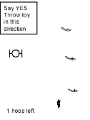

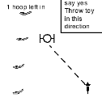

“INS” or “COME”

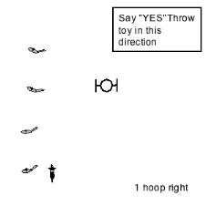

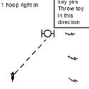

Here is an example of One Hoop Work. This is one of the first few times my puppies did a hoop. Watching the video again, I could have had more time between my verbal release and my motion. I am always verbally releasing my dog , although you can always hear it in the video. And note I am saying “YES” when they go through the hoop.
http://www.youtube.com/watch?v=WDjXbyqESBo&feature=youtu.be

TWO/THREE HOOPS ANGLED:
Angle the hoops so that you have to work OUTS and INS.
SHOW ME QUICK VIDEO OF 2/3 ANGLED HOOP WORK

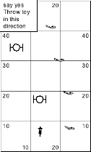

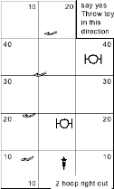

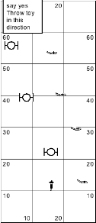

TWO HOOP DISCRIMINATION Start with Hoops farther apart (about 15 feet) then move to almost touching. Vary your location. SHOW ME QUICK VIDEO OF 2 HOOP DISCRIMINATION WORK

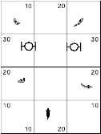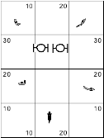

MULTIPLE HOOP DISCRIMINATIONS Add hoops before the discrimination. Start with one hoop before the discrimination and work up to 2 or more. Start with Discrimination hoops farther apart (10-15 feet) then move then closer. Work both sides and vary handler position. SHOW ME QUICK VIDEO

https://www.youtube.com/watch?v=Nhgw93kdgNA
https://www.youtube.com/watch?v=y0DIoSrT7IE&feature=youtu.be

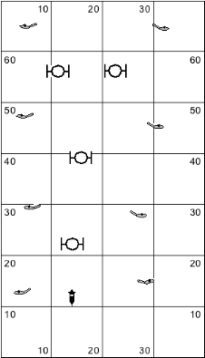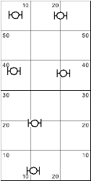

NOTE on Hoops: When I am teaching new skills, I use hoops not jumps to work the exercises. I don’t want to worry about the dog jumping when working new skills. I also like to use hoops in training as I believe hoops make your handling better. There is no time to be late with your cues with hoops. When you are using jumps, you have a little bit more time to cue your dog as the dog needs to prepare to jump and then jump. Once my dogs have the skills I am working on, then I will add jumps to the exercises.

WHAT AM IN LOOKING FOR??
Do you have a good startline and release?
Are you releasing on VERBAL release ONLY?
Did you draw the dog’s path with your arm/hand/finger?
Is your arm dropping at the correct time? Is your arm coming out at the correct time?
Where are you looking (eyeballs)?
Are you cues consistent and clear?
Are you saying “YES” or some other word to let your dog know exercise is over toy is coming?
Are you rewarding in the general location you want your dog to go?
Is your dog driving through hoops?

