Feb 20 jumpers , Circle, Switch Flip Boxes and Distance

Circle of jumps
http://www.youtube.com/watch?v=-gcljKPxk18

http://youtu.be/XpnCnpQut6s

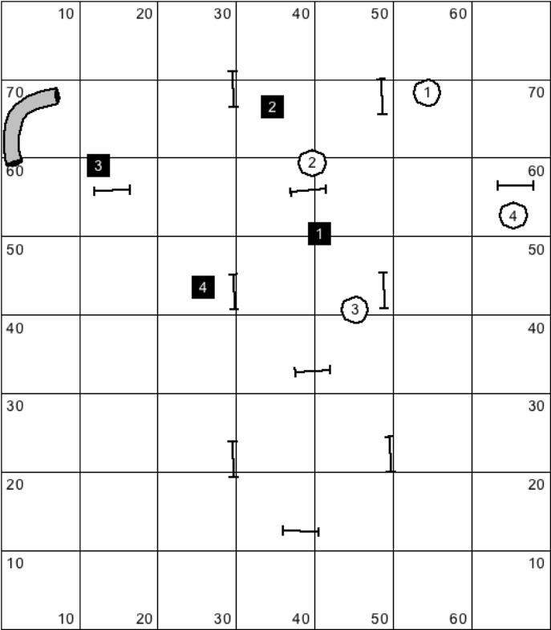

DISTANCE 2 jumps/ Front Cross Dist
http://youtu.be/nCmwvjJRAZU

http://youtu.be/iaOG32F4oQY
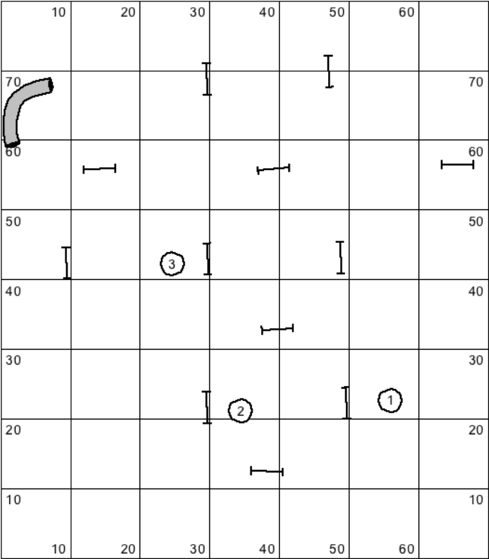

DISTANCE 1-3
Layer lines of jumps
Layer the 2nd layer of jumps
http://www.youtube.com/watch?v=4Udq9HECr1k

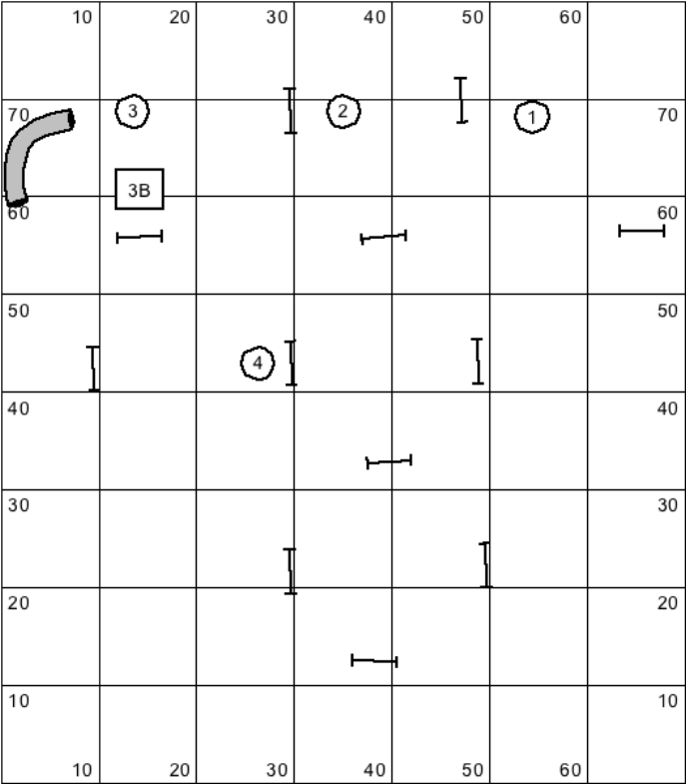

1-5
Layer 1st layer jumps
Layer 2nd layer
REAR CROSS 2-3
Reverse --
PRACTICE REAR CROSS
http://youtu.be/1KtIAHJAlRM
http://youtu.be/-5sN5IZj5wM
http://youtu.be/9Cv5VCkflw0
http://www.youtube.com/watch?v=pr7CiCYjgr4

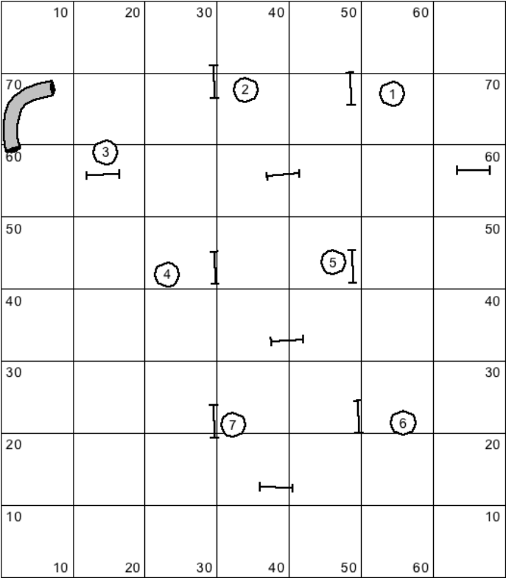

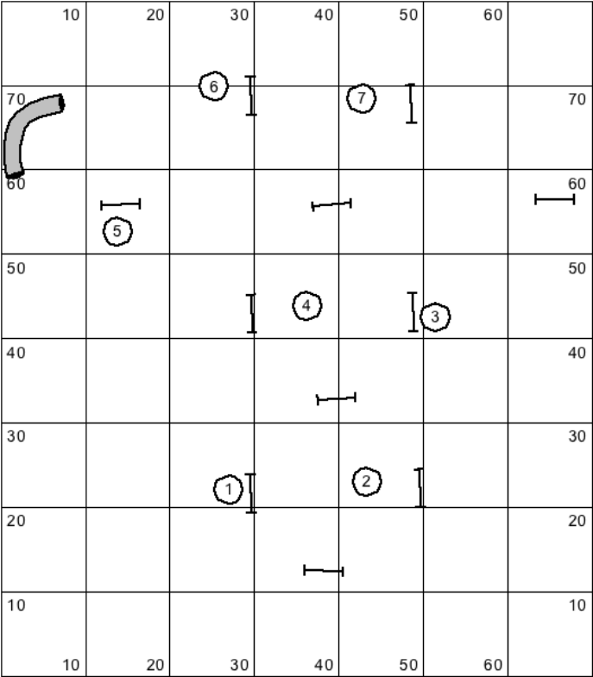

THROUGH BOX TO CIRCLE
Do both Pull and Rear Cross to 4
Practice being inside circle and outside circle (no or short leadout)

http://youtu.be/D_Sjdr_EvHA
http://youtu.be/j3WflSyQet4

