July 22 2014
Start with hoop dogwalk, or barrel tunnel
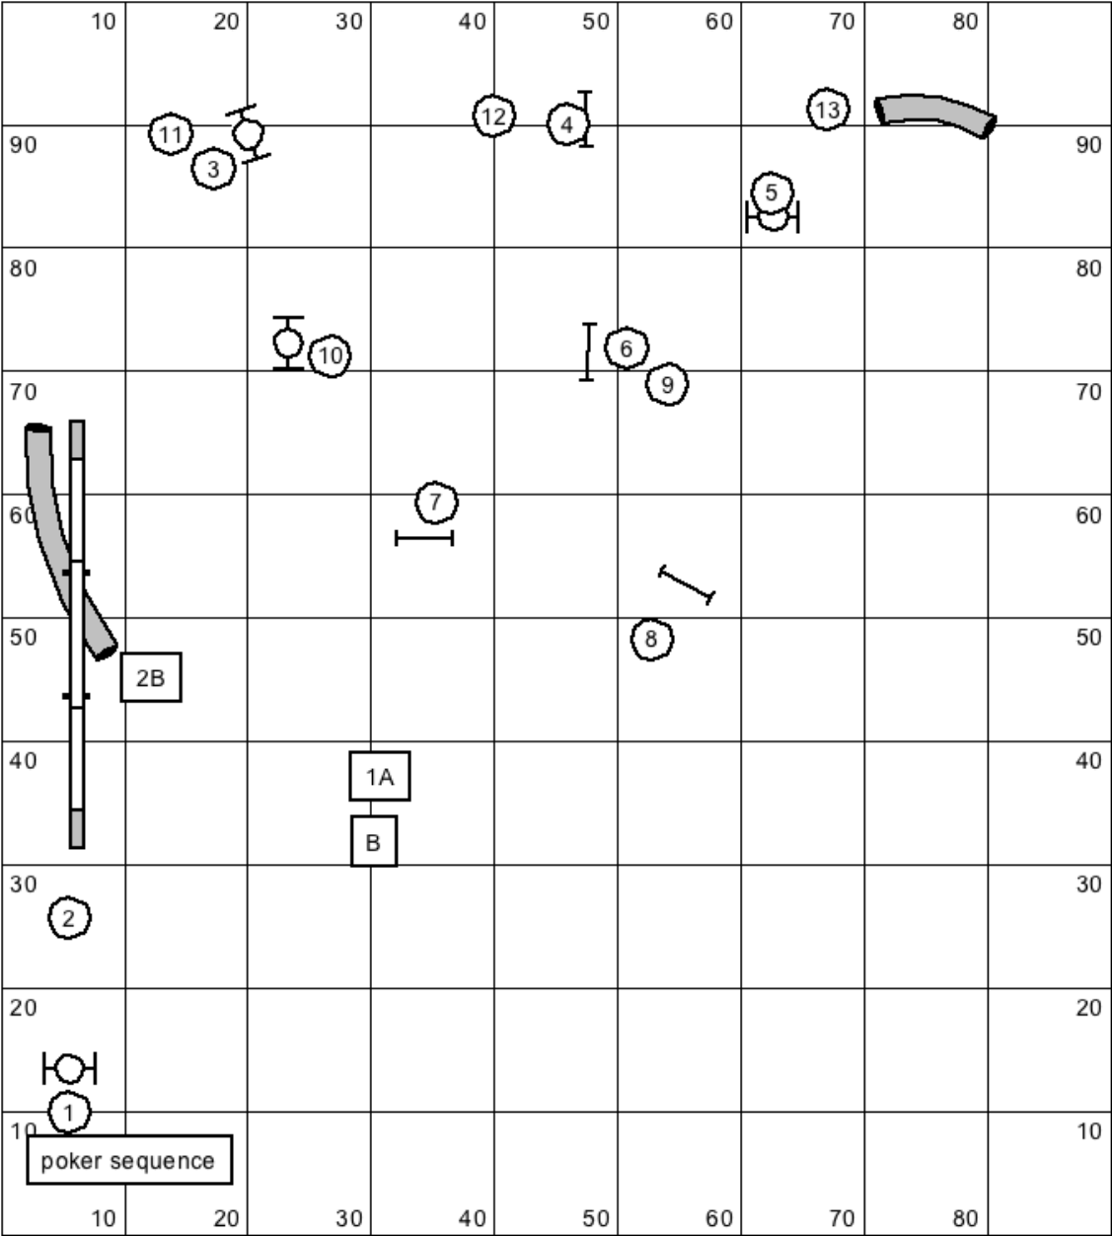

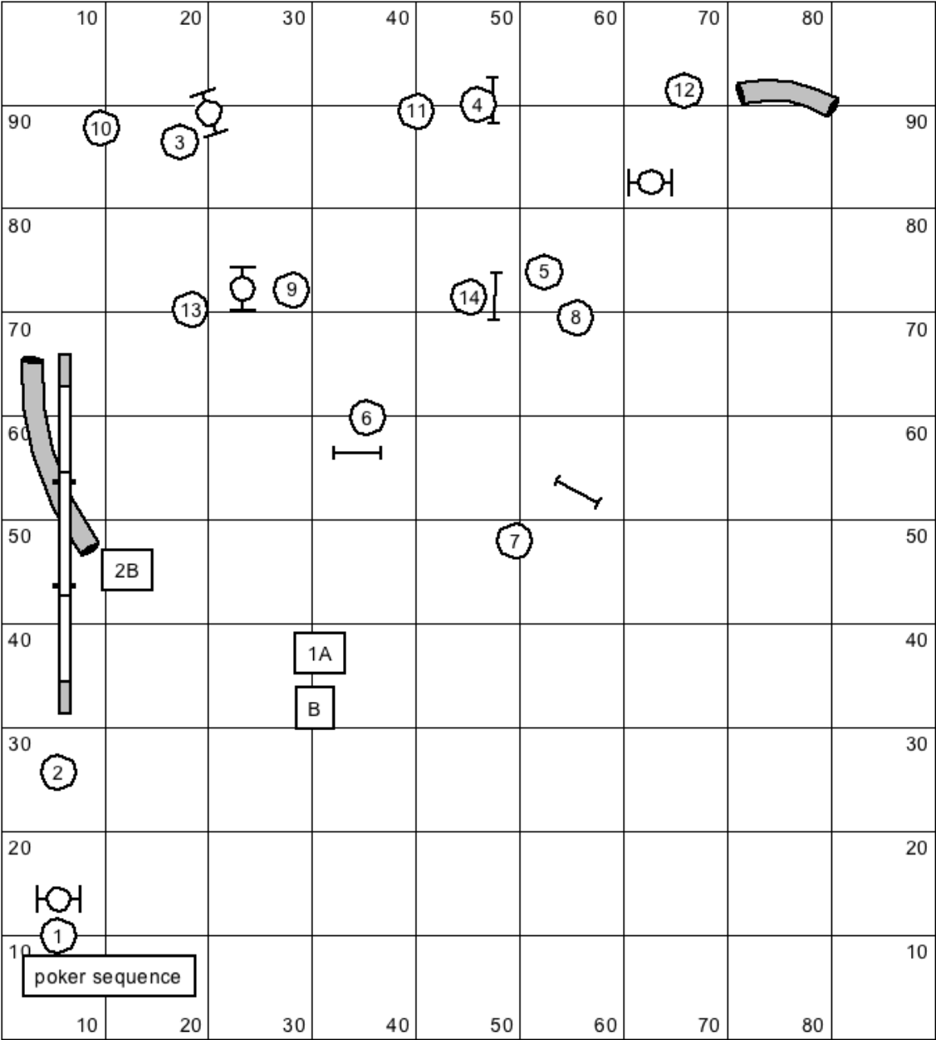

Start with hoop dogwalk, or barrel tunnel
End with dogwalk hoop or tunnel

http://youtu.be/AjIAeY7qPBs

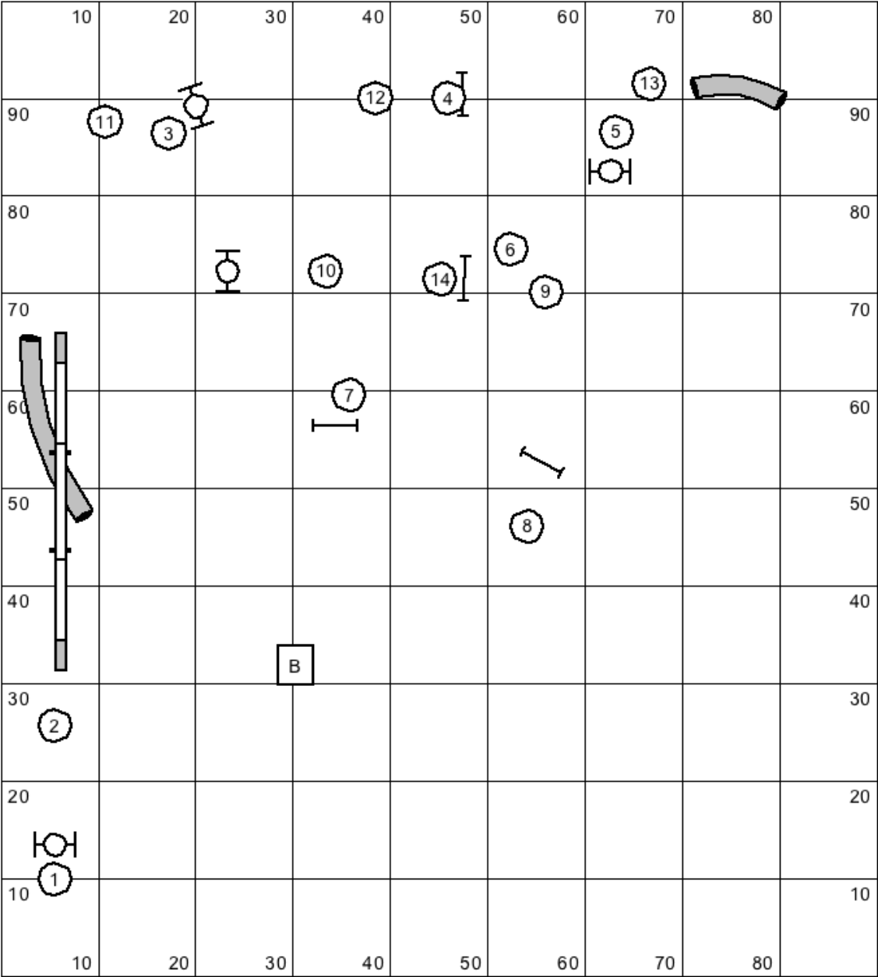

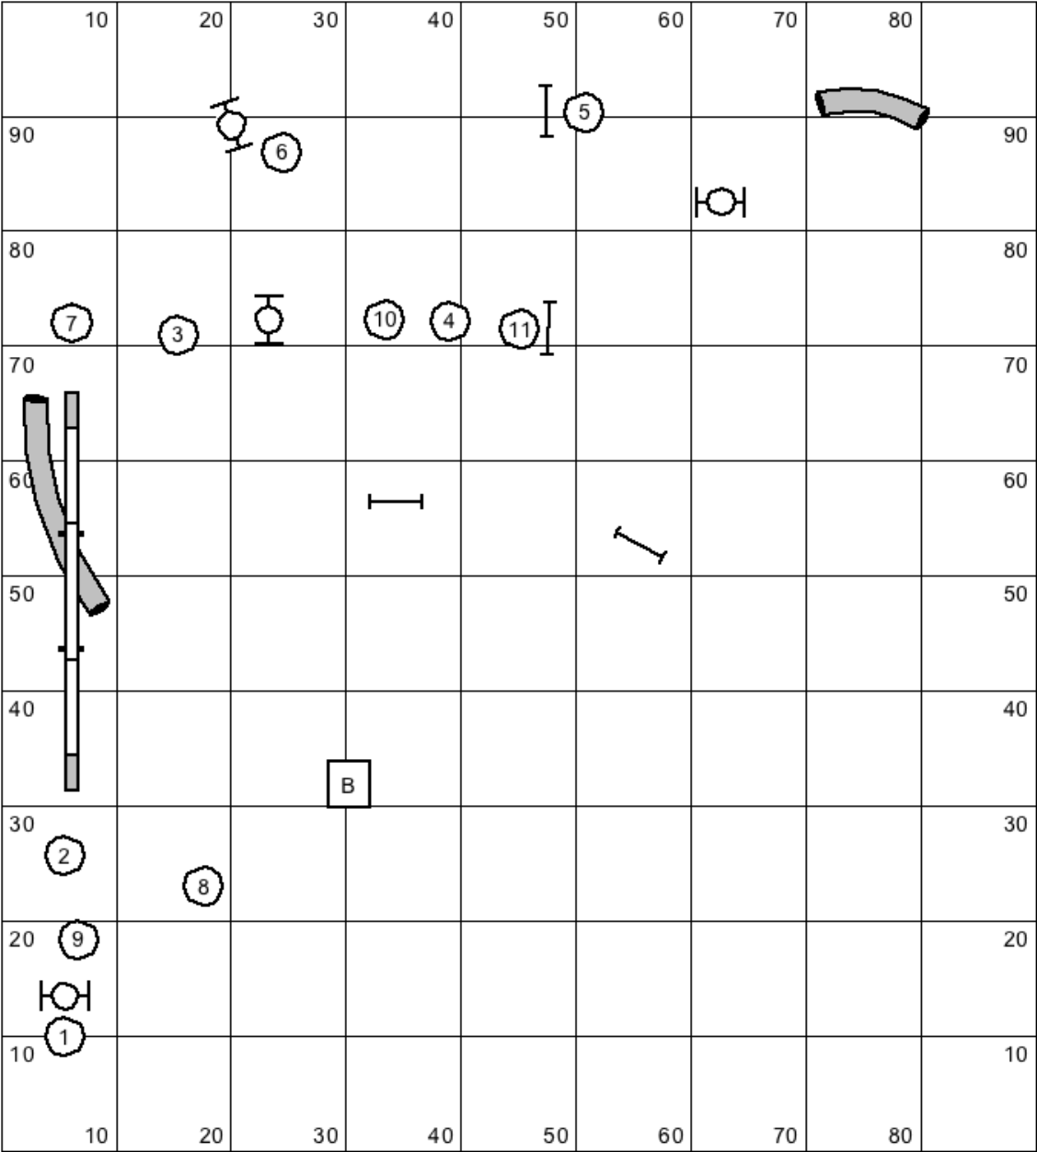

http://youtu.be/ptOcetIbk7I

http://youtu.be/YynTmLPBF3Y

http://youtu.be/J2jxp2694fM

http://youtu.be/MxFJ8abr4VE

