NEVADA CHANCES
Switch off starting #1 with walk /tunnel
Switch off discriminations at 10

This course is a GREAT example how important it is to walk the dog’s path and for you to draw that path. When I ran a variation of this chances course, I did not walk the path …so I did not see how hard it was to get 9 !!

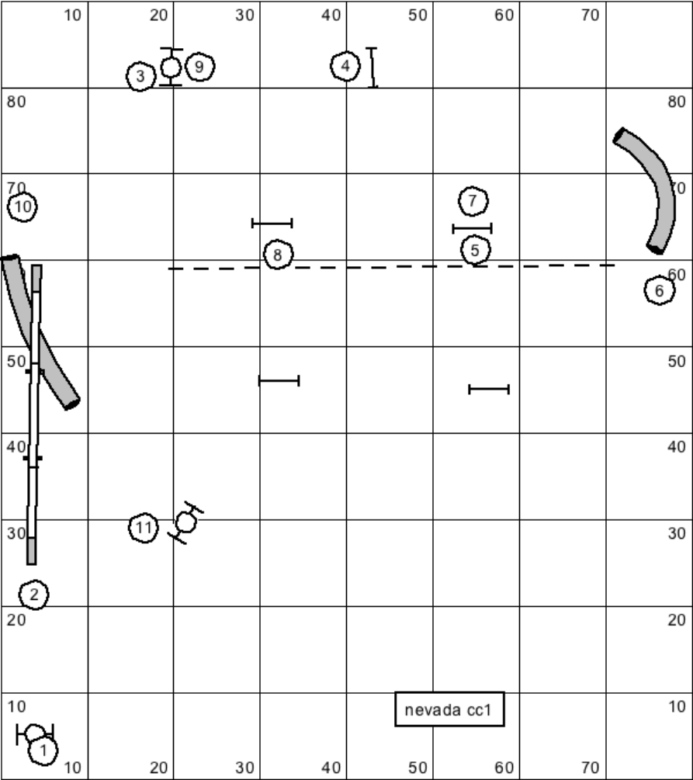

If you don’t set up the correct line from 7-9, dog will miss 9 like below.

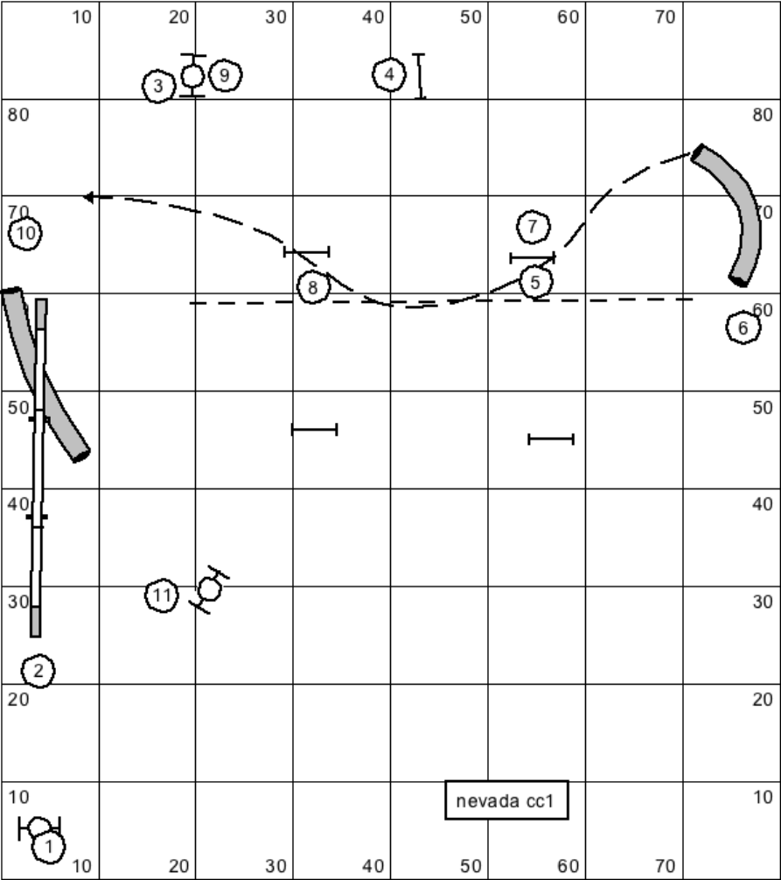

You need to let dog ‘drift’ past 7 to get the good line to 9.

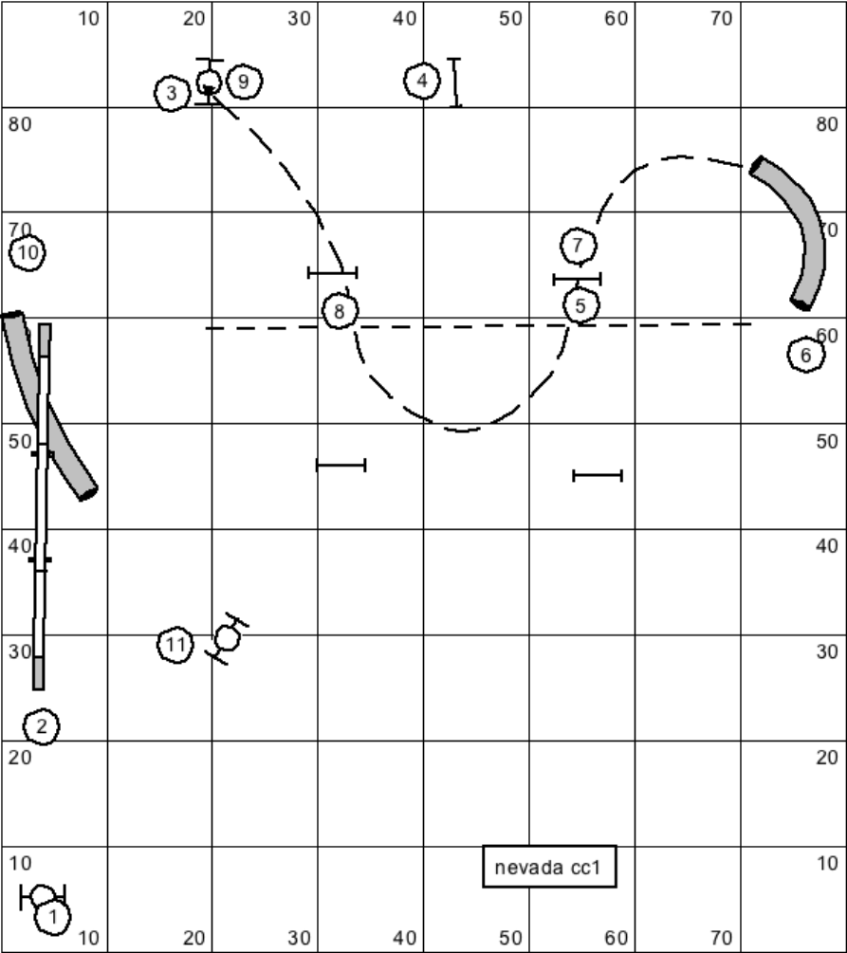

SO how do you set the line??
If am between jump 5 and tunnel- I let dog drift past 5 and then did a tight switch on the ground. Once dog is lined up to 8 I say “FLIP” (before dog gets to 8) to get 9.

When I was to the left of jump 5, I had to turn into my dog- draw my path with my left hand and hold the line and then push out to 9 with my right arm.
http://youtu.be/VINK99fx5h8

In the video, I walked the path so you can see the dog’s path and how important it is to set the dog up.

SEQUENCE 2: Again, make sure you walk the path so you see what the dog sees and what line you need to put your dog on. You need to let the dog drift out past 6 to set up the line to get 7-8. If your dog turns tight out of tunnel

http://youtu.be/SnyumFydL2Y

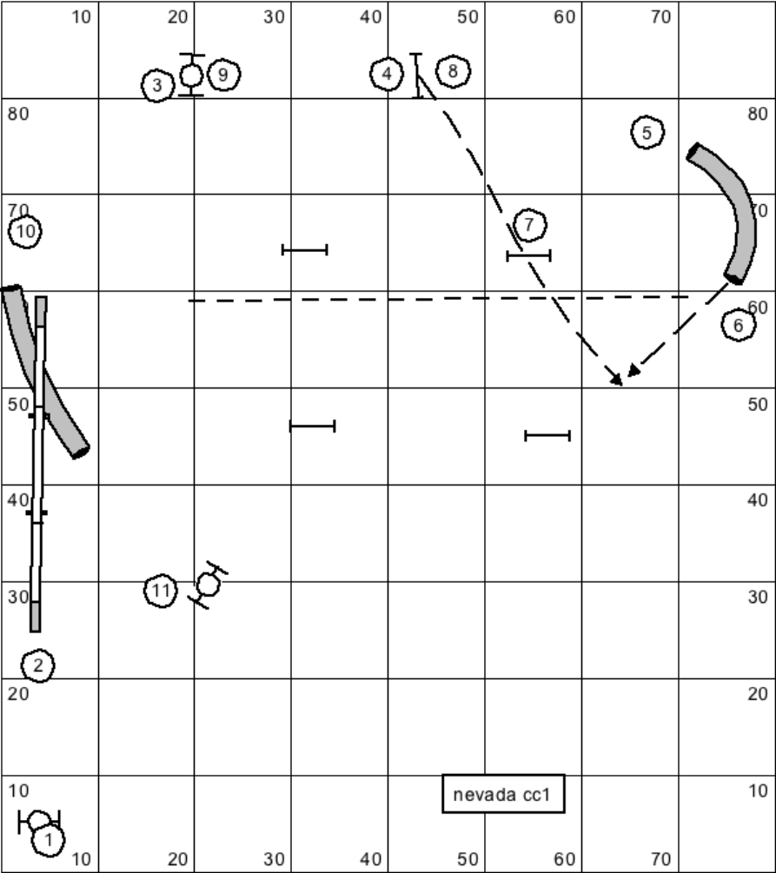

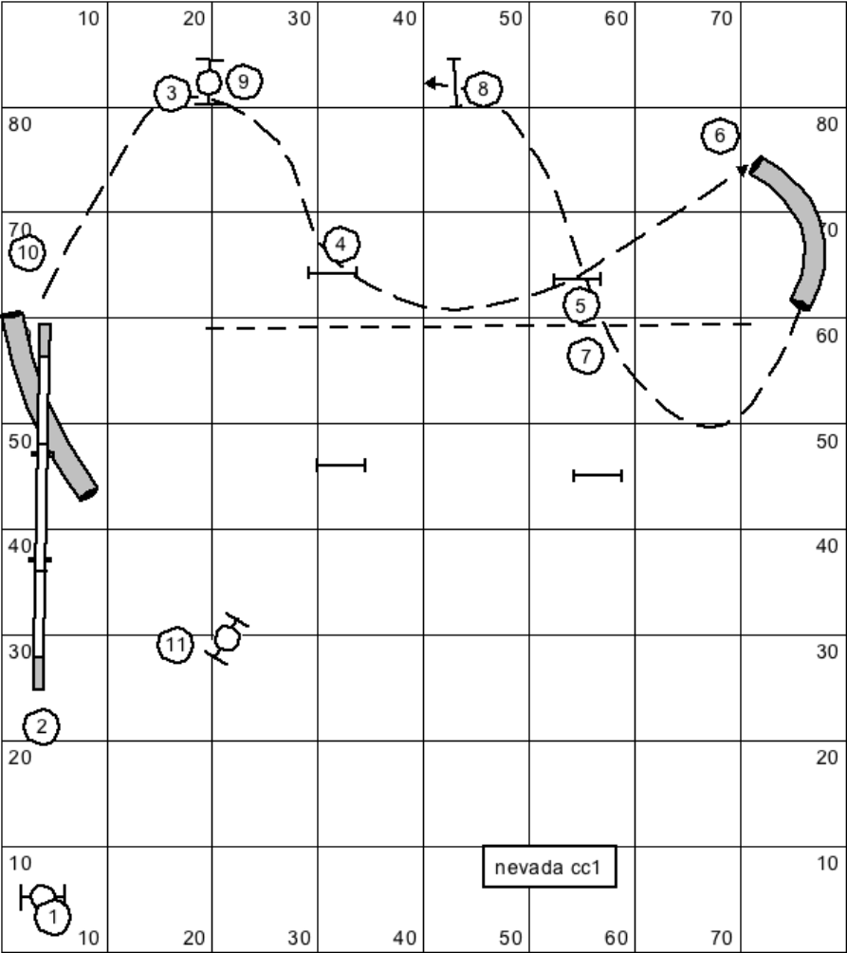

SEQUENCE 3:
http://youtu.be/DcMlNqcTLh8

