PROOFING FLIPOFF Sept 2014

For some reason, on occasion (more often than I would like !!) my dogs ‘flip’ off me… I go one way and they go the other. I honestly, cannot figure out why……

Here is me doing real “FLIPS” http://youtu.be/CDMfbFUKgAU

Here is video dogs ‘flipping off me “ WRONG
http://youtu.be/YI5hqV7bc4k

Here are some sequences to work this.

http://youtu.be/KmaAQ-iY0mI
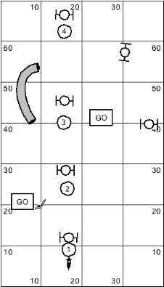

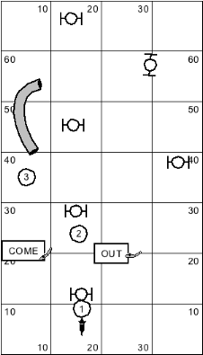

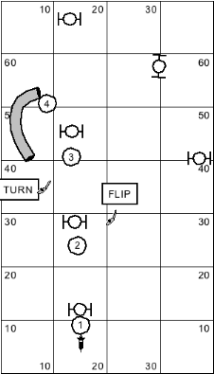
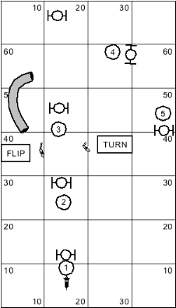

http://youtu.be/Jq2NYgj9woQ

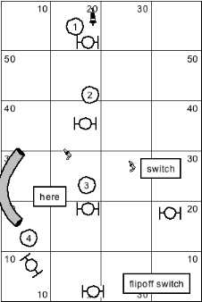

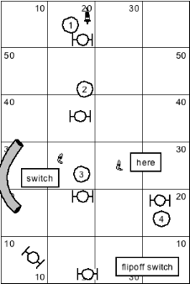
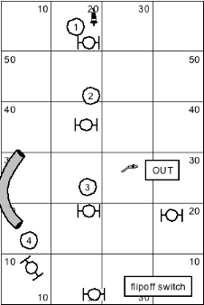
http://youtu.be/L_VzkLs3f7A

