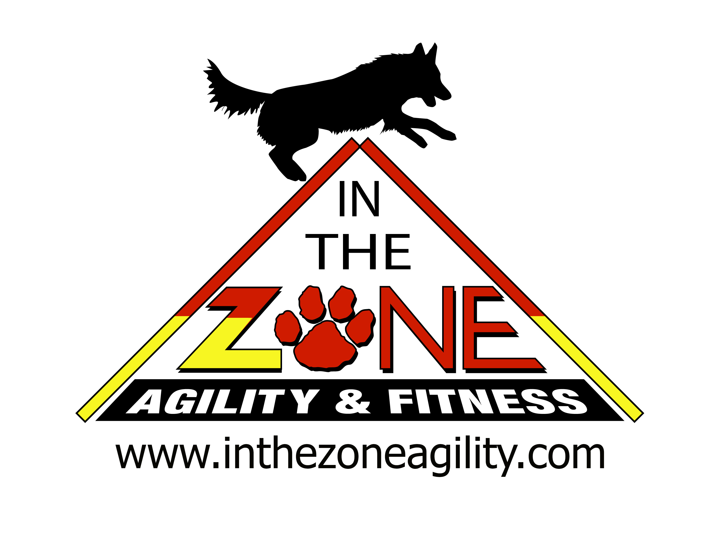
In The Zone, LLC  May 6 7 8  May 13 14 15  Salem County  Fairgrounds, Woodstown NJ  735 Route 40, Woodstown, NJ 08098 – http://www.salemcountyfair.com/map.pdf  Outdoors on Grass  Judge:  May 6-8: Karen Hough  May 13-15: Sarah Fix  DOUBLE RUN FORMAT  Contact Surface:  Rubber  Crating Set up times:  Friday/ Sat/Sun 7:30  Briefing at:  Friday/  Saturday /Sunday 8  First dog on the line at:  After briefing | Preliminary Class Order:  May change depending on weather, judges preference, time or number of entries  May 6-8  Double Run for all 3 days  Friday Saturday Sunday  Gamblers Jumpers Regular  Regular Tunnelers TouchnGo  Weavers Weavers Chances  Jumpers Regular Grounders  May 13-15  Double Run for all 3 days  Friday Saturday Sunday  Gamblers Regular Tunnelers  Chances Jumpers Regular  TouchnGo Weavers Chances  Regular Tunnelers Grounders

Entries Open on:Now  Entries Close April 25  Please send in your entry before April 18th. I will be out of town after that and will head to the trial. If you are entering after that, please email me your entry and bring a check to the trial.  Please bring a copy of the COVID release to the trial.  Double Run  Entry Limits 50 PEOPLE and or :400 runs a day  Move ups: Allowed  DAY OF SHOW ENTRIES  : $15 a run  REFUNDS: There shall be no refunds for entries withdrawn in the event a dog and/or handler are dismissed from competition, regardless of the reason for such dismissal. If the trial needs to be cancelled during the trial due to weather, no refunds will be given.  Full Refunds will be given if you cannot come because you are sick or have been in contact with someone that is sick  “An inherent risk of exposure to COVID-19 exists in any public place where people are present. COVID-19 is an extremely contagious disease that can lead to severe illness and in some cases death. By entering and attending this trial , you voluntarily assume all risks related to exposure to COVID-19." | Show Committee  Lisa Schmit  inthezoneagility@gmail.com  Confirmations will be sent out by the Monday before the trial.  ENTRY CHANGES: Accepted entries may be changed prior to Wednesday before the trial at 9:00 p.m. E-mail change requests to Lisa Schmit at inthezoneagility@gmail.com NO CHANGES will be made at the trial, so please read over your confirmations carefully.  Awards and Ribbons:  1st-4th Place, Q Ribbons,  Special Award Ribbons- NATCH, Versatility NATCH, Platinum NATCH, Triple Triple Superior, Triple Superior Versatility  Equipment info:  A-Frame, Dog Walk, Jumps, Open Tunnels, Hoops, Barrels, and 24” Spaced Weave Poles  Food info:  No drinks. Please bring your own.

Jump Height Info:
MEASURING
Measurement forms may be obtained at:
https://www.nadac.com/WPsite/wp-content/uploads/2021/06/Permanent-Height-Card-form-6.4.21.pdf
Dogs which require measuring:
Dogs in the Proficient Category, Novice, Open or Elite jumping 4”, 8”, 12” or 16”

Dogs which do not need to be measured:
Dogs jumping 16” in the Veteran or Junior Handler Division
Dogs jumping 20”
Dogs in the Skilled Category
Dogs with a permanent height card
Dogs listed on the Height Exemption List
JUMP HEIGHTS
There are four Standard Division-Proficient jump heights: 8”, 12”, 16”, and 20”.
There are four Standard Division-Skilled jump heights: 4”, 8”, 12”, and 16”.
There are four jump heights for the Veterans and Junior Handler divisions: 4”, 8”, 12”, and 16”.
Please see the NADAC Rulebook for the full jump height table

Brief Summary of Rules:
Please refer to www.nadac.com for a full explanation of all NADAC rules and up to date information.

- Please note that NADAC trials should provide a safe and fun environment for both exhibitors and their dogs.
- Aggressive dogs will not be tolerated and will be excused from the trial.
- The show committee has the right to refuse any entry. Anyone not currently in good standing with NADAC will not be allowed to enter this trial.
- Exhibitors, through submission of entry, acknowledge that they are knowledgeable of NADAC rules and regulations, and agree to abide by all rules in effect at the time of this trial.
- No entry fee will be refunded if the trial cannot open or be completed by reasons of riots, civil disturbances, fire, acts of God, public emergency, an act of a public enemy, or any other cause beyond the control of the organizing committee.
- Checks not honored by the bank do not constitute a valid entry fee. There will be a $25.00 service charge for bank returned checks.
- Dog must be registered and have a valid registration number before entries will be accepted. https://www.nadac.com/register-your-dog/
- A copy of the current Exhibitors Handbook may be downloaded free from the NADAC web site: www.nadac.com
- Bitches in heat, lame, or blind dogs are ineligible for entry, as is any dog with a deformity which may cause a judge to not be able to reasonably assess the dog’s ability to function and perform agility obstacles safely, and in a manner that is in the best interest, health and welfare of the dog.
- No food, clickers, or other aids or devices shall be permitted on the course or within 10 feet of the ring. Food or a small non-audible toy can be in a secure container (ziplock bag is acceptable) in your pocket during your run but it cannot be used during your run, nor can you indicate to the dog it is there. All handlers my bring a non-audible toy into the ring for training purposes. They cannot earn a Qualifying score and must declare to the judge they are training before they commence their run. Please read the Exhibitor’s Handbook for more information about toys and training in the ring.
- The sponsoring clubs will not be responsible for the loss or damage to any dog exhibited, or for the possessions of any exhibitor whether the result be accident or other cause. It is distinctly understood that every dog at this event is in the care and control of his owner or handler during the entire time the dog is on the show premises.

In The Zone, LLC, May 6-8 and May 13-15 Woodstown NJ
Send entries to: Lisa Schmit, ITZ NJ Trial, 14670 Nave Rd, Mechanicsburg IL 62545
Please mail your entry early. I will be leaving IL April 19th and won’t be back until after the trial. If you are entering after that, please email me your entry.

Owner |  |  |  |  |  |  | Dog
Name |  |  |  |  |  |  | Call Name
Address |  |  |  |  |  |  | NADAC Reg #
City/State/Zip |  |  |  |  |  |  | Date of Birth
Phone |  |  |  |  |  |  | Height at Withers
Email |  |  |  |  |  |  | Breed
Handler, If not owner |  |  |  |  |  |  | Emergency Contact Name/Phone
 |  | PLEASE INCLUDE A COPY OF YOUR DOG’S HEIGHT CARD IF YOU DO NOT HAVE ONE ON FILE.
 |  | CATEGORY: PROFICIENT SKILLED
 |  | DIVISION: STANDARD VET DOG VET HANDLER JUNIOR HANDLER
 |  | I WANT MY DOG TO JUMP: 4 8 12 16 20
Class | Level |  |  |  |  |  | Day
 | Intro | Nov | Open | Elite | Friday  May 6 | Sat  May 7 |  | Sunday  May 8 | Friday  May 13 | Sat  May 14 | Sunday  May 15
Chances |  |  |  |  |  |  |  | Rd 1 Rd 2 | Rd 1 Rd 2 |  | Rd 1  Rd 2
Jumpers |  |  |  |  | Rd 1  Rd 2 | Rd 1 Rd 2 |  |  |  | Rd 1  Rd 2
Regular |  |  |  |  | Rd 1  Rd 2 | Rd 1 Rd 2 |  | Rd 1 Rd 2 | Rd 1  Rd 2 | Rd 1  Rd 2 | Rd 1  Rd 2
Gamblers |  |  |  |  | Rd 1  Rd 2 |  |  |  | Rd 1 Rd 2
Grounder |  |  |  |  |  |  |  | Rd 1 Rd 2 |  |  | Rd 1 Rd 2
TouchnGo |  |  |  |  |  |  |  | Rd 1 Rd 2 | Rd 1  Rd 2
Tunnelers |  |  |  |  |  | Rd 1 Rd 2 |  |  |  | Rd 1  Rd 2 | Rd 1  Rd 2
Weavers |  |  |  |  | Rd 1  Rd 2 | Rd 1 Rd 2 |  |  |  | Rd 1 Rd 2
 |  | In consideration of the acceptance of this entry, I/we certify that I/we have knowledge of, and are familiar with, and agree to abide by, the Rules and Regulations of NADAC in effect at the time of this trial, and by any additional rules and regulations as approved by NADAC for this trial. I/we certify that the dog entered is not a hazard to persons or other dogs. I/we further agree to be bound by the “Agreement” printed on page 5 of this premium

Number of Total Runs Entered (all dogs):
1- 11 Runs = $13 a run
12 -20 Runs= $12 a run
21 –40 Runs $11 a run
41 -55 $10 a run
56 and over $9 a run
Junior Handler = $5 each
Day of Show (AFTER CLOSING DATE) $15 a run

TOTAL ENCLOSED =___________

Owner/Exhibitor: ____________________________________Date______________________

Parent or Legal Guardian of Junior Handler_________________________________________
AGREEMENT
The person who signs this agreement represents that he/she is authorized to enter into this agreement on
behalf of both exhibitor and the owner of entered dog. In consideration of acceptance of this entry:
1.1. As used here "NADAC" means the North American Dog Agility Council, LLC., its members,officers, directors, employees, show chairs, show committees and agents.
1.2. Exhibitor/owner agree to abide by the rules and regulations of NADAC and any other rules and
regulations appearing in the premium for this event.
1.3. Exhibitor/owner certify that the entered dog is not a hazard to persons, dogs or property and that
the entered dog's rabies vaccination is current in accordancewith the requirement of the state in whichthe dog resides.
1.4. Exhibitor/owner acknowledge all hazards presented by the event and the event premises,
including, but not limited to, the condition of the surface, restrooms, security measures or lack of,
electrical appliances, fittings, show rings, parking areas and the presence of unfamiliar animals and
people; exhibitor and owner assume the risk of any harm arising from these.
1.5. Exhibitor/owner releases NADAC (including its respective officers, directors, employees, and
members), In The Zone, LLC (including its officers, directors, members, and event organizing
committee), Lisa Schmit-Bonker, UpNOver, LLC and Salem County Faigrounds including its officers, directors, members, and event organizing committee), and will defend them and hold them harmless from all present and future loss, injury, damage, claims, demands and liabilities involving the entered dog, the event or event premises. Without limiting the generality of the foregoing hold harmless provisions, exhibitor/owner hereby specifically assumes sole responsibility for and agrees to indemnify and save the aforementioned parties harmless from any and all loss and expenses (including legal fees) by reason of the liability imposed by law upon any of the aforementioned parties for damages because of bodily injuries, including death, at any time in consequence of my (our) participation in this event, howsoever such injury or death may be caused and whether or not the same may have been caused or may have been alleged to have been caused by negligence of the aforementioned parties or any of their employees or agents or any other persons

THE MANAGEMENT: will not be responsible for the loss or damage to any dog exhibited, or for the possessions of any exhibitor whether the result was by accident or any other cause. It is distinctly understood that every dog at this event is in the care, custody, and control of his owner or handler during the entire time the dog is on the show premises. Any exhibitor whose dogs and/or children create unnecessary disturbances or repeatedly engage in unsafe or disruptive behavior may, at the discretion of the Show Committee, be asked to leave the show site. In such case, no refund of fees paid will be made and no scores will be submitted

In The Zone, LLC cannot guarantee your safety and good health. But we are making many adjustments to make this trial as safe as possible. Remember, despite all the plans we put in place, you still need to be aware of the basics: WASH YOUR HANDS AND WASH THEM OFTEN AND MAINTAIN SOCIAL DISTANCING. If you feel sick, stay home. You will receive a full refund!!
If you contract COVID-19 within 2 weeks of attending the trial, please let me know.

“An inherent risk of exposure to COVID-19 exists in any public place where people are present. COVID-19 is an extremely contagious disease that can lead to severe illness and in some cases death. By entering and attending this trial , you voluntarily assume all risks related to exposure to COVID-19."

PLEASE PRINT THIS AND BRING TO THE TRIAL. PLEASE PRINT 1 FORM FOR EACH PERSON TRAVELING WITH YOU.
ASSUMPTION OF THE RISK AND WAIVER OF LIABILITY RELATING TO CORONAVIRUS/COVID-19
This Form must be completely filled out by each attendee and participant, including children.
The novel Coronavirus (“COVID-19")has been declared a worldwide pandemic by the World Health Organization. COVID-19 is extremely contagious and is believed to spread mainly from person-to-person contact. As a result, federal, state, and local governments and federal and state health agencies have recommended social distancing and have, in many locations, prohibited or limited the congregation of groups of people. The North American Dog Agility Council, LLC, (hereinafter “NADAC”), has put in place preventative measures to reduce the spread of COVID-19; however, NADAC, cannot guarantee that you will not become infected with COVID-19. Further, attending and/or participating in a NADAC trial could increase your risk of contracting COVID-19.
By signing this document, I acknowledge the contagious nature of COVID-19 and voluntarily assume the risk that I may be exposed to or infected by COVID-19 as a result of attending and/or participating in a NADAC trial and that such exposure or infection may result in personal injury, illness, permanent disability, and death. I understand that the risk of becoming exposed to or infected by COVID-19 at a NADAC trial may result from the actions or inactions of myself or others. I voluntarily agree to assume all of the foregoing risks and accept sole responsibility for my decision to attend and/or participate in a NADAC trial, and any personal injury, disability, illness, death, damage, loss, claim, liability, or expense of any kind, that I may experience or incur in connection with my participation in a NADAC trial.
I hereby release, covenant not to sue, discharge, and hold harmless NADAC, its directors, officers, employees, agents, representatives, volunteers, members, successors, and assigns, local trial hosts, judges, and participants from any and all liabilities, claims, actions, damages, costs or expenses of any kind arising out of or relating to my attendance and/or participation in a NADAC trial. I understand and agree that this Assumption of Risk and Waiver of Liability Relating to Coronavirus/COVID19 covers any claims based on the action or inactions of myself, NADAC, its directors, officers, employees, agents, representatives, volunteers, members, successors, and assigns, local trial hosts, judges, and participants, regardless of whether a COVID-19 infection occurs before, during, or after participation in any NADAC trial.
Dated: ______________ __________________________________________
Signature
Minor Child Name: _________________ __________________________________________
(if applicable) Signature Parent/Guardian of Minor Child
*If more than one child, a separate from must be completed for each child.
Accepted by Local Trial Host: __________________________________________
Signature Local Trial Host Representative
Accepted by NADAC, LLC upon execution.

PARKING & RV & CAMPING INFORMATION: $20 per night fee and there are electric hookups (no dump station).. Please note that the RV hookups are not real close to the agility ring. Please do not send RV payments, but pay Lisa or Cathie at the trial. Tent camping is also permitted. There are showers.
HOTELS
A block of rooms has been set up starting Thursday 5/5 – Sunday check out 5/14
Holiday Inn Express in Carney’s Point, NJ 506 S. Pennsville Auburn Road, Carney’s Point, NJ 856-351-9222 The hotel is 15 minutes from the trial site. $129/night plus tax. Pet Fee is waived (normally $30 per night now). A limited number of King rooms and Double rooms are available on a first come basis. Each room has microwave and mini fridge. Block rate ends April 25th Call hotel directly. Block name is “Dog Agility”. You may need to remind desk manager at check in that the pet fee has been waived as per the manager, Manjunath.

Holiday Inn Swedesboro, NJ 1 Purland Drive, Swedesboro, NJ 856-467-3322 The hotel is 20 minutes from the trial site. Rate is $119.00/night plus tax AND a $75 per reservation pet fee. If you check in, check out and return for the next weekend, you will pay another $75 fee. A limited number of King rooms and Double rooms available on a first come basis. Each room has a microwave and mini fridge. Breakfast at the restaurant is included, however, I am told the restaurant opens at 7AM on weekends. Block rate ends on April 14. Block name is “DAA”

You may also want to look at:
Red Roof Inn Plus Wilmington-Newark
415 Stanton Christiana Road, Newark, DE
302-292-2870
Hotel is about 25 minutes from the trial site. There is no block set up. Please check rates. There is a $5.00 toll from NJ to DE on the Delaware Memorial Bridge
As a reminder, the Comfort Inn in Carney's Point is no longer dog friendly!

Directions to Salem County Fairgrounds:
735 Route 40, Woodstown, NJ 08098 – http://www.salemcountyfair.com/map.pdf
From the Delaware Memorial Bridge: Cross the bridge and follow signs for Rt. 40 East. The Salem County Fairgrounds is approximately 7 miles on the left.
From I-295: Take Exit 2B, at 2nd traffic light make a left onto Rt. 40 East. The Salem County Fairgrounds is approximately 7 miles on the left.
From NJ Turnpike: Take Exit 1, take last exit before the bridge. Follow signs for Rt. 40 East. Salem County Fairgrounds is approximately 7 miles on the left.
From the East: Take Rt. 40 West through Woodstown. At the light on the west side of town, Rt. 40 makes a right turn. Turn right and continue on Rt. 40. Go straight through the next light. Cowtown Rodeo will then be on your left. The Salem County Fairgrounds will be on the right, approximately 1/4 mile past Cowtown.

MORE INFO

Leash Running: We are allowed to keep our leashes on person. It can be wrapped around your waist or shoulder.just not your neck. You can also put leash in your pocket. As a club, we are required to have a leash runner if you do not want to do this. Please let me know if you need a leash runner by checking the box on the entry form. This way I can plan for having a worker for that class.

We will have a VERY brief "in person" briefing on Friday and Saturday to address any last minute changes. But please limit your questions to only what is absolutely necessary. Please stay at least 6 feet (if not more) away from anyone else. Briefing notes will be send via email before the trial.

Ribbons will be self-serve. (a) please wait if someone is already at the table, please wait until they are through before you get yours. (b) please sanitize your hands both before and after getting your ribbons.

We of course need volunteers to make this trial run smoothly. If you are a bar setter volunteer, please bring your own lawn chair with you when you come into the ring, and take it when you leave.

The ring gates will be open unless you request otherwise. If you want them closed then ask the person in front of you to close the gate as they leave, and you close the entry gate as you enter.

Remember this is a Double Run Format Trial. We run the same course twice with no walk through in between. We will run EE OO NN for most classes except we will run EE ONON for Tunnelers and Touch N Go. You MAY (but do not have to) run the same dog twice in round 1 and then go get your other dog to run twice in round 2. Whatever works for you and your dog.
PLEASE TAKE YOUR TIME BETWEEN RUNS. WE WILL WAIT FOR YOU!!!!!!!!!!! DO NOT RUSH YOURSELF OR YOUR DOG!!
Thank you so much for coming and please enjoy yourself!!!

