CAPITOL CANINE TRAINING CLUB
Presents Two Workshops with Lisa Schmit

February 25, 2018
Capitol Canine Training Club Building, 209 E. Walnut, Chatham, IL
8:30 am - 12:30 pm and 1- 5 pm
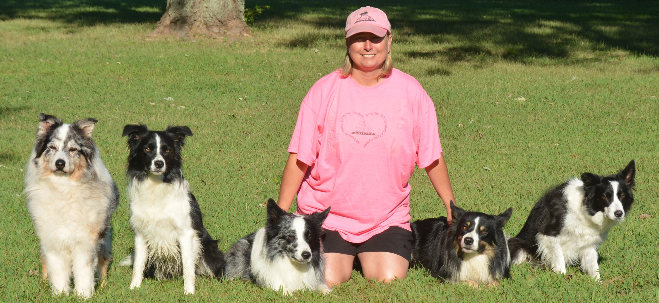
Lisa Schmit, PhD, CCFT, CPMP has been active in agility for over 20 years. She is a NADAC Certified Clinician, Certified Pet Massage Practitioner, FITPAWS Master Trainer, Certified Canine Fitness Trainer and a member of Bobbie Lyons’s K9 FitClub. She gives seminars across the country. To view a complete list of her accomplishments, videos of runs and photos please visit http://inthezoneagility.com
Workshop 1: Groundwork for Cues, Connection and Distance 8:30 am – 12:30 pm; $75
The key to success is having a strong foundation. There is so much you can do to train agility and distance without agility equipment. In this workshop, we will go over my foundation exercises including detailed shadow handling, targeting using toys and target buckets, and using toys to teach cues and crosses. I teach distance without agility equipment. We will also add some obstacle work to show how to use the groundwork skills on course. All levels of teams are welcome from beginner teams that need to learn these skills to more advanced teams that want a tune-up.
Workshop 2: Canine Fitness Fun 1 – 5 pm; $75
This hands-on workshop will focus on teaching dogs to use their bodies to increase balance and general fitness. Dogs will learn fitness exercises on the flat and then on balance equipment (Fitbones, pods, balance disc, benches). You will get time to practice them so you understand how to perform the exercises properly. We will go over a proper warm-up and cool down routine. We will also teach proper and safe body placement for exercises with and without equipment.
The CCTC building is approximately 45 ft X 55 ft; the working area is a bit smaller. Inside crating space is available in the small training room. Each workshop will be $75 with a maximum of 8 dog/handler teams in each. You may also do both workshops for $125.
Please provide proper payment with this completed form to Linda Hinsman at 1205 Ravenswood Drive, Springfield, IL 62711 before February 16. Please make checks out to CCTC. Preference will be given to CCTC members who have submitted their completed form with payment to Linda Hinsman on or before February 16, 2018. Registration will then be open to non-members. Unlimited auditors are welcome.

Participant Information (please print or type)

Name

Dog’s Breed

Dog’s Name and Age

Participant’s Email
Each workshop is $75. You may do both workshops for $125.
I would like to be in: workshop 1: ☐ 8:30 am – 12:30 pm workshop 2: ☐ 1 – 5 pm Both workshops: ☐
I, the undersigned, hereby agree that CCTC, Inc. its members, officers, and the presenter/instructor, shall not be held responsible for any injury, damage or loss that my dog or I might receive while attending training sessions or while on club property. I further agree to pay for any injury or damage that my dog may cause to other animals, people or property while on CCTC property.

Signature |  | Date

